**Sprint 3 Retrospective**

|  |  |
| --- | --- |
| Group | 1 |

Members:

|  |  |  |  |  |
| --- | --- | --- | --- | --- |
|  | Tyler Angelier |  |  | Rick Boles |
|  | Michael Montgomery |  |  | Mallory Helms |

* **Bring a printed, stapled copy of your *Sprint 3 Retrospective* to the demo.**
* **Place a copy of your *Sprint 3 Retrospective* (and images) in the root folder of your master branch on GitHub.**
* **Make sure there is a README.md file in your repository as specified in the Sprint 3 Plan, Requirement 3.**

**Sprint 3 Plan Summary**

1. Provide a list of methods that have not been developed:

|  |  |
| --- | --- |
| **Class** | **Method** |
| N/A | N/A |

1. Provide a list of methods that are buggy and/or not fully tested:

|  |  |  |
| --- | --- | --- |
| **Class** | **Method** | **Comments** |
| N/A | N/A |  |

1. If you used an online tool for designing your GUI, fill out this table:

|  |  |
| --- | --- |
| **Site Name** | N/A |
| **Site Address** | N/A |
| **Tool Name** | *N/A* |
| **What did you liked about tool?** | N/A |
| **What did you not like about tool?** | N/A |

1. Display your GUI design below. Use a whole page if needed. Place your image in the root folder of your master branch on GitHub.

Our first meeting, design, and brainstorm:



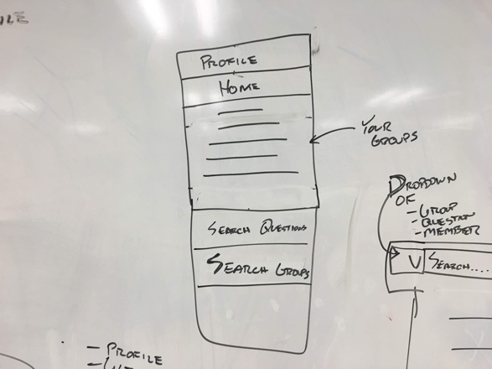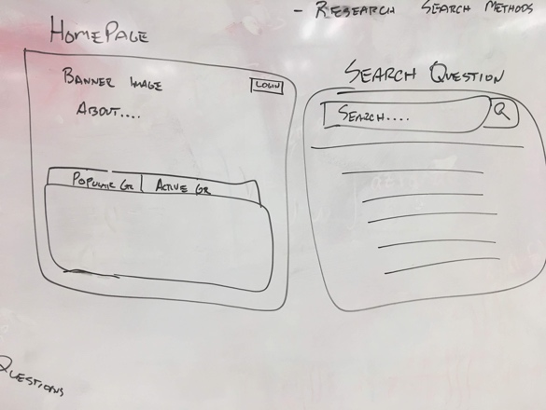 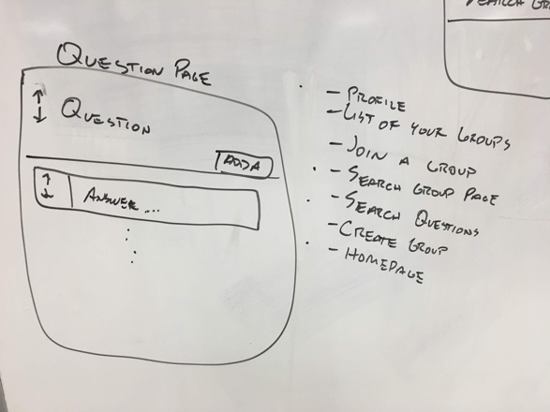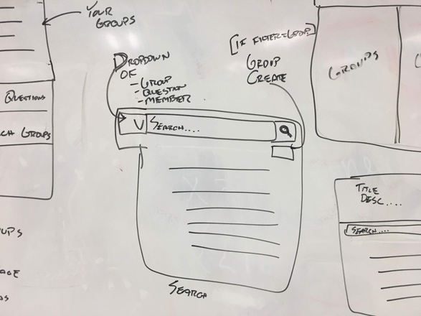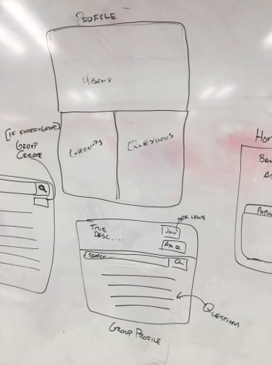

A refined approach after researching various technologies:

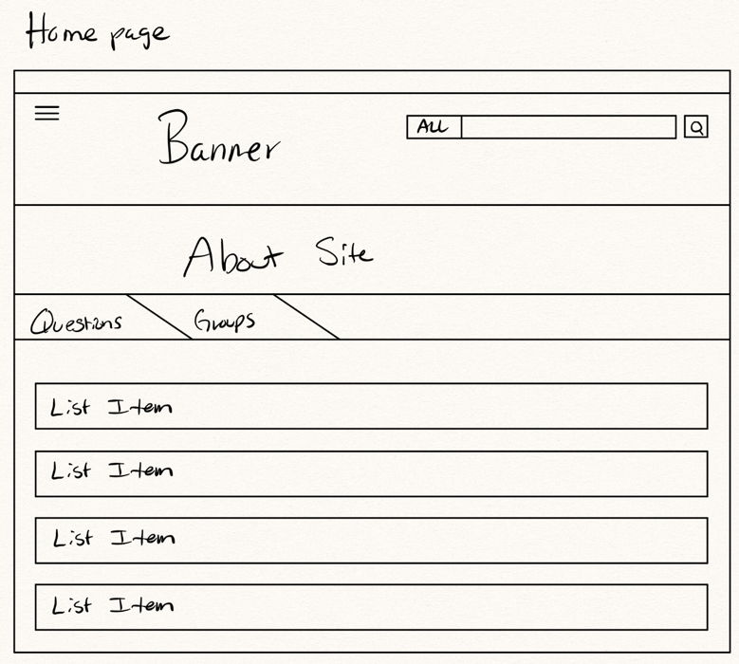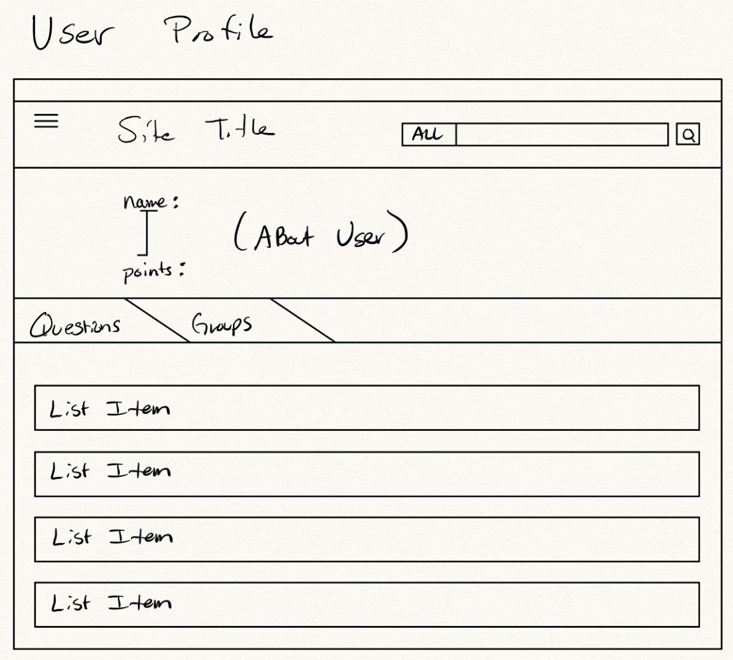

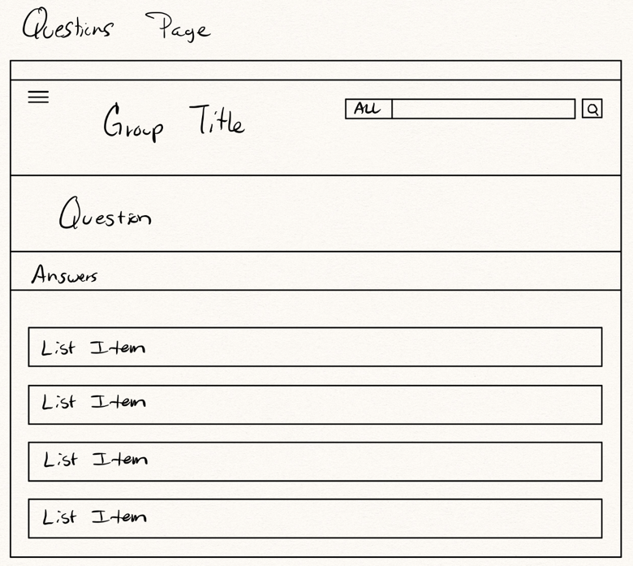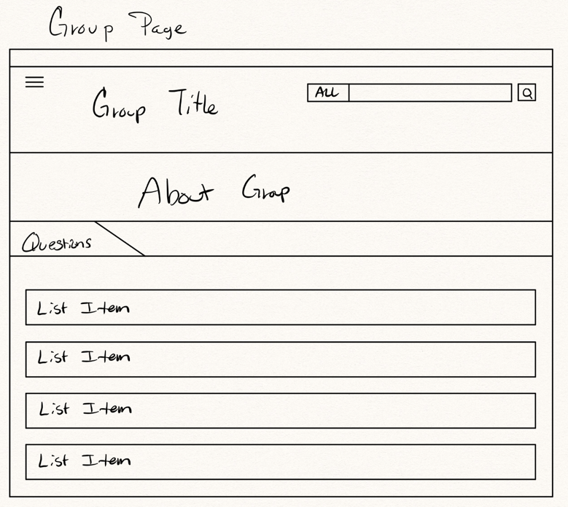

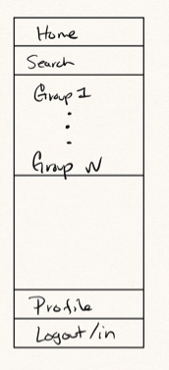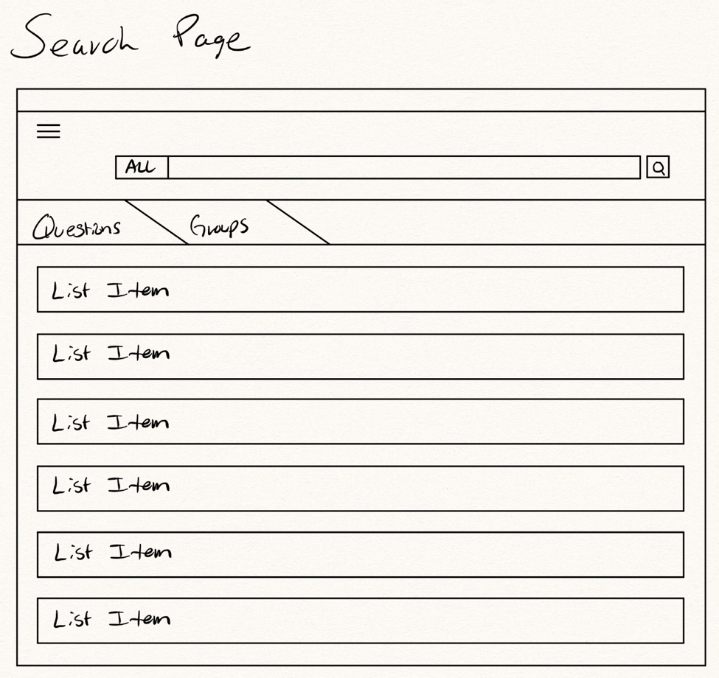

This is our design fully implemented.

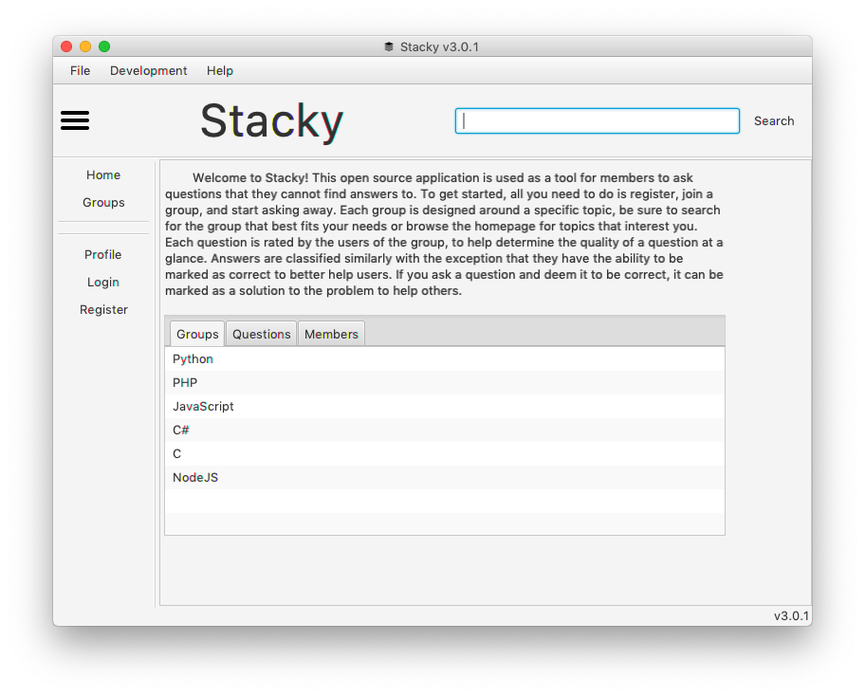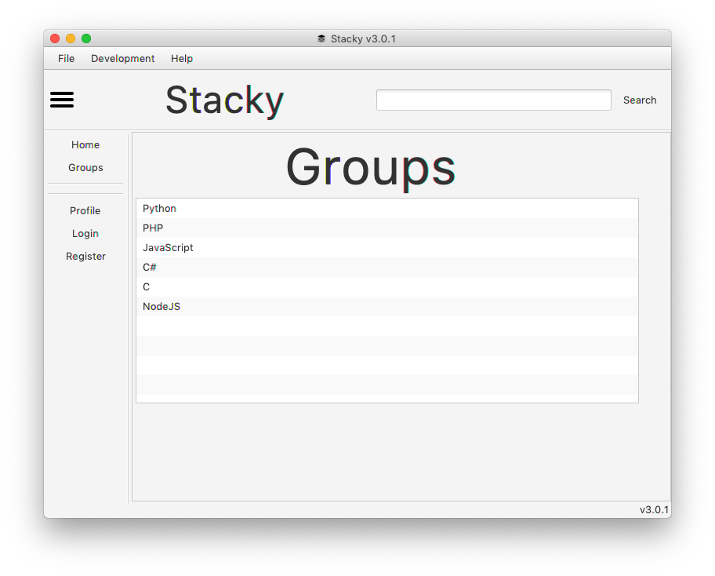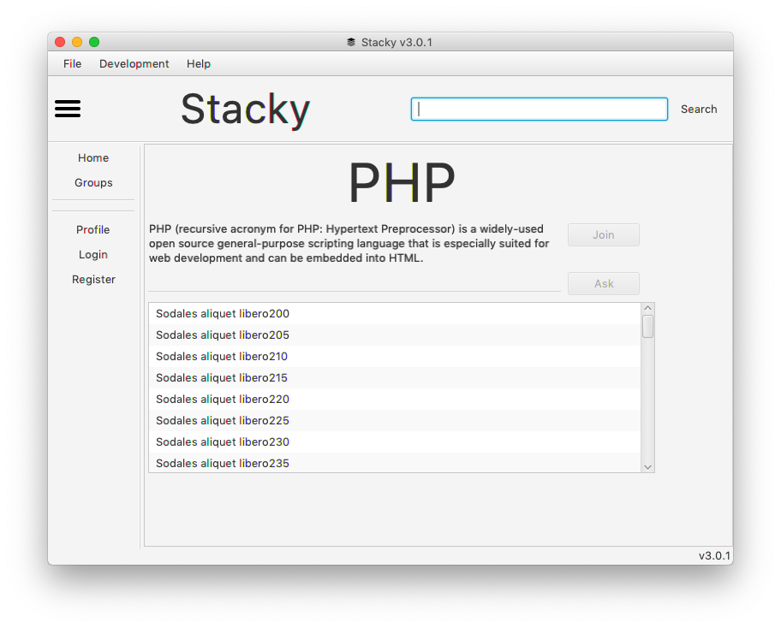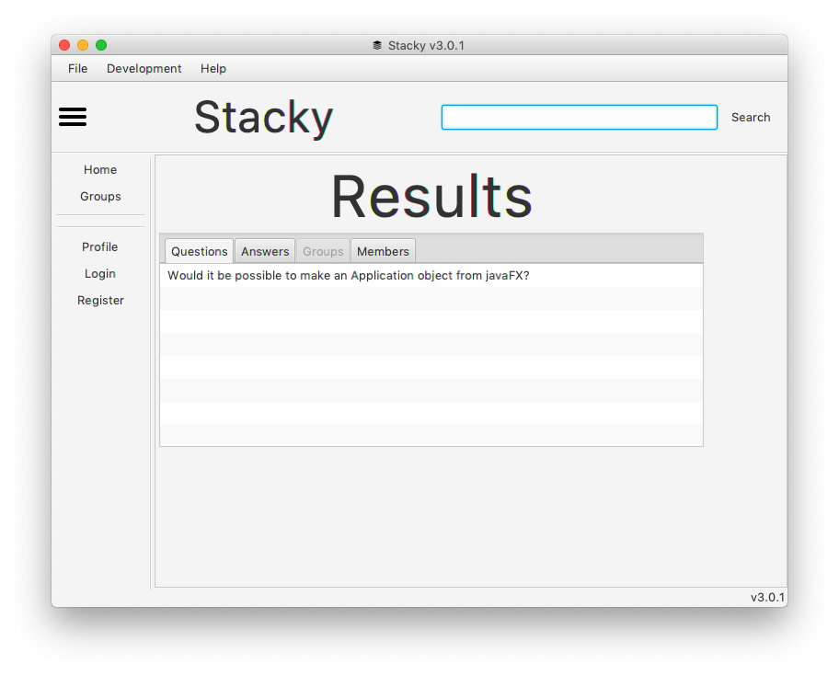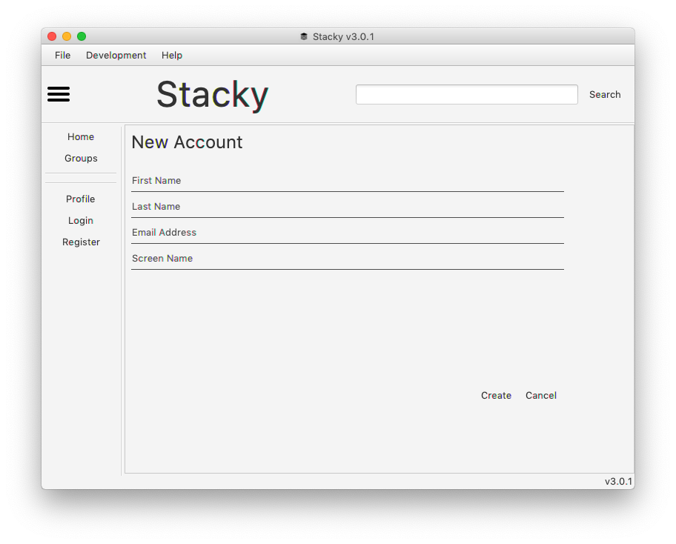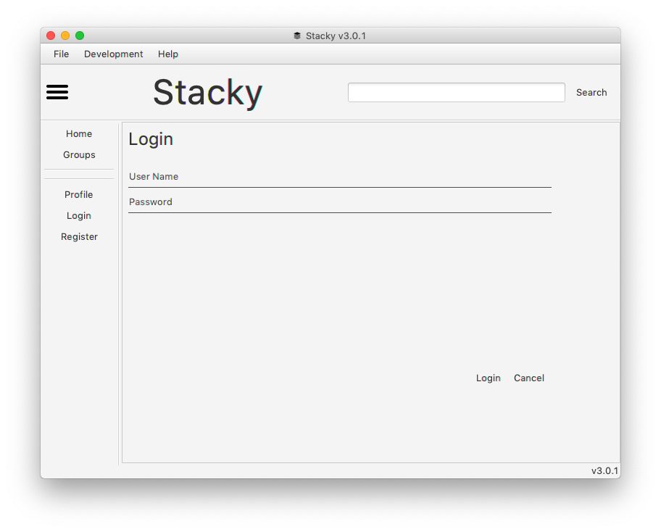

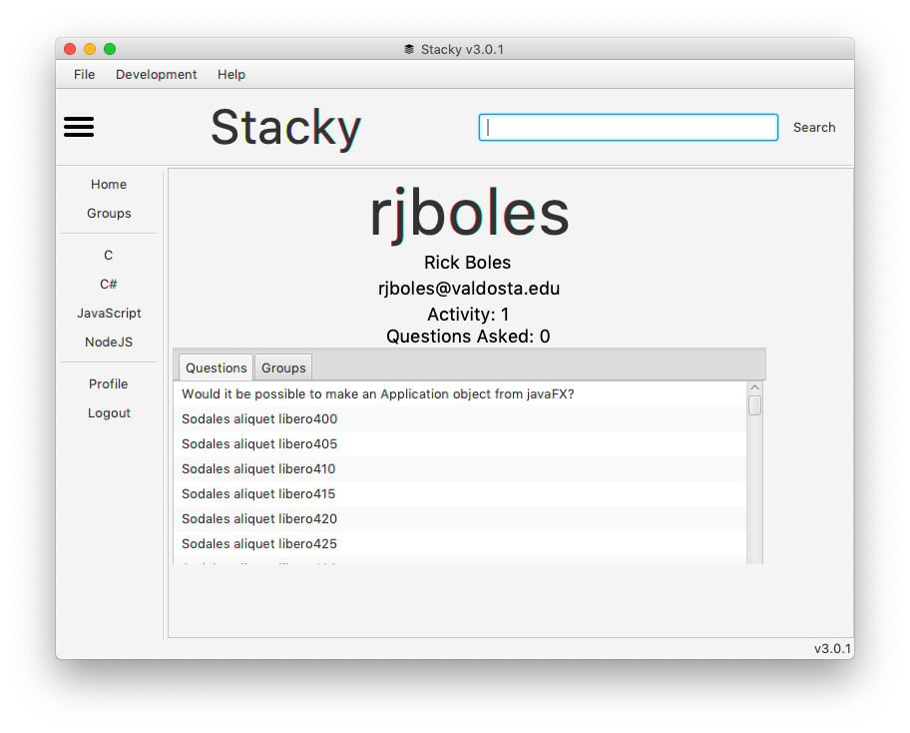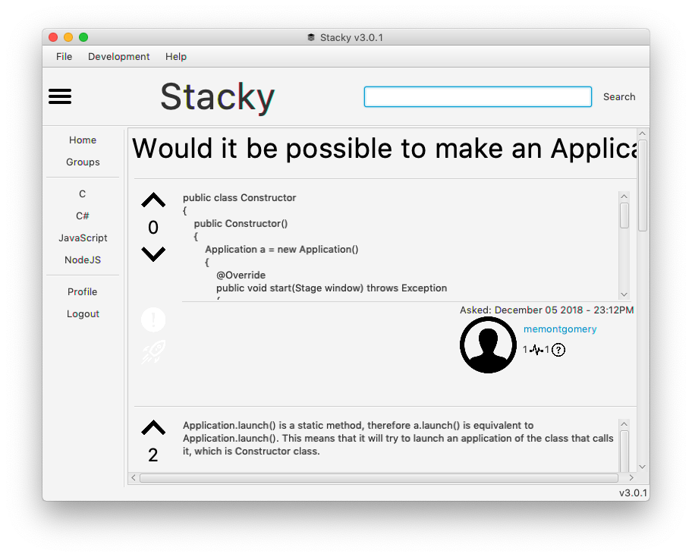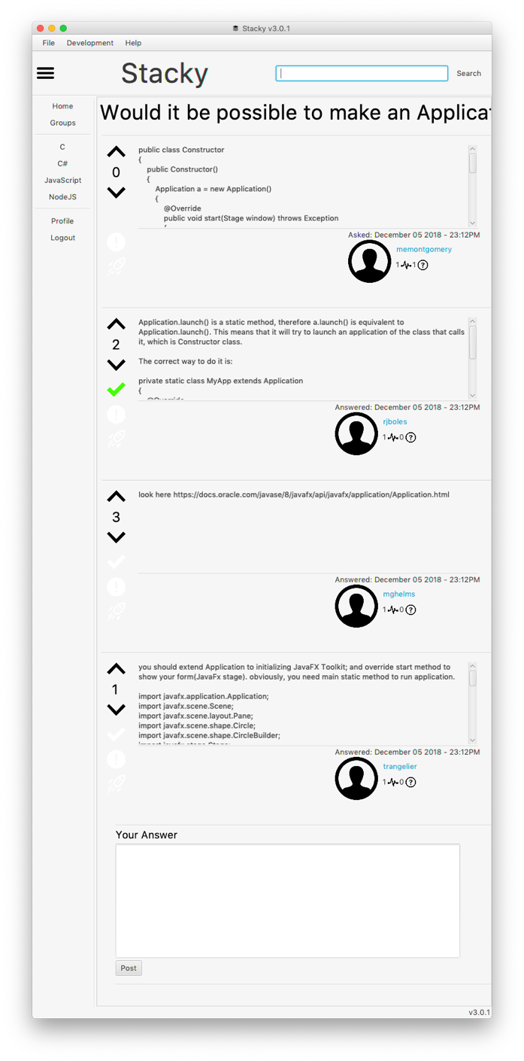

**Sprint 3 Retrospective**

Meet as a group and discuss the three questions below. Provide a thorough written response to each question below:

|  |  |
| --- | --- |
| **Question** | **Answer** |
| Discuss ways that your group’s ability to work as a team evolved over the 3 sprints. | Teamwork:   * In each sprint it became more and more apparent that each member of the team would “fill” a certain role. By Sprint 3 we all had a good understanding of each other’s role and would create issues and assign tasks based on these roles. * Jordan was a great organizer; he would jump from issue to issue, no matter what they were, always be available for pull requests, and always be up for long coding sessions. Tyler lead many design meetings by taking input from everyone and organizing it into a cohesive thought, and by using general principles of software design. Mallory was extremely valuable for her code review, bug finding, and ability to find more efficient patterns. Mickey was very useful for tidying up loose ends in the codebase. |
| Discuss what you are most proud about your project. | What we are the proudest of:   * Our ability to work as a team to develop a refined front end that runs cleanly on our backend. * The education and development of JavaFX from start to finish. (Including JAR File) * Our thorough bug testing with calculated improvements of our framework. * The overall project management through the use of GitHub issues and project boards. Throughout all three sprints, we generally maintained the workflow of create an issue, assign it, work on it, push to an individual’s branch, create a pull request, get it reviewed, and then merge to the master branch. * Jordan and Tyler did not fight a single time… :D |
| Regardless of the effectiveness of your team, discuss ways you could improve your team work. | Team work improvements:   * There should have been a better split of types of work among each of the members of our team. While having a role/specialty and taking those tasks which relate to it is a good thing, doing the same type of code can easily lead to burn out or developer sloppiness. * We were also prone to procrastination. This was an issue for all of the sprints. Planning was always done early but development was frequently put off. Once the team got going on the development side we worked hard but that initial push was often after the halfway point of the sprint. There could have been more effort put into motivating each other to get started on the tasks we had put in the issues. |